12 • The Gas Laws
FORMULAE

STP = 0°C = 273 K and 1 atm 1 atm = 760 torr = 760 mmHg = 101.3 kPa

Boyle’s Law P₁V₁ = P₂V₂  Charles’ Law $\frac{V_{1}}{T_{1}}$= $\frac{V_{2}}{T_{2}}$  Gay-Lussac’s Law $\frac{P_{1}}{T_{1}}$= $\frac{P_{2}}{T_{2}}$  Combined Gas Law $\frac{P_{1}V_{1}}{T_{1}}$= $\frac{P_{2}V_{2}}{T_{2}}$  Ideal Gas Law PV = nRT | n = $\frac{m}{M}$ m = mass; M = Molar Mass  M = $\frac{\text{mRT}}{\text{PV}}$  = $\sqrt{\frac{\text{mass B}}{\text{mass A}}}$  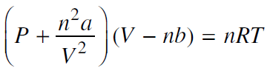 | Ideal Gas Constant, R  = 0.0821  $\frac{P_{A}}{P_{\text{TOTAL}}}$=$\frac{{\text{moles}}_{A}}{{\text{moles}}_{\text{TOTAL}}}$  KE = 1/2 m·v2

